

CMPT 3830: Machine Learning
Work Integrated Learning-1

Project Report: Phase 1
Project Title [ALPACA]

In collaboration with



Submitted By:

Name | ID | Email
Manpreet Kaur Loyal | 3132175 | mloyal@norquest.ca
Kirandeep Kaur | 3122707 | kkaur707@norquest.ca
Ramon Rabusa | 3102642 | rrabusa@norquest.ca

Submission: Date: [Feb 27’ 2026]
Winter 2026

Table of Contents:
A table of content is required with section numbers, names with correct page numbers. An example is shown below.

Contents
List of Figures: 3
List of Tables: 4
1. Project Phase: 5
2. Team Members’ Name with specific roles 5
3. Reporting Period: [Specify the reporting period, e.g., Month/Year to Month/Year] Key breakdown of each part submission. 5
4. Project Overview: Overview with the problem statement and solution approach you followed. 6
5. Dataset 6
5.1 Exploratory Data Analysis (EDA) Highlights: 7
5.2 Visualization: 10
6. Challenges Encountered: 19
7. Stakeholder Engagement: 19
8. Lessons Learned: 20
9. Risk Management: 21
10. Future Recommendations: 21
11. Impact on the Community: 21
12. Project Conclusion: 21
13. Acknowledgments: 22
14. Appendices: 22
15. References 23

List of Figures:

Figure 1: Correlation Matrix 10
Figure 2: Loyalty Adoption Rate 11
Figure 3 Revenue per Visit 11
Figure 4: Visit Frequency (Loyalty vs Non-Loyalty) 12
Figure 5: Distance by Loyalty Status 13
Figure 6: Average Visits per customer by Make 14
Figure 7: Average Service Revenue by Month (YoY) 14
Figure 8: Customer Behavior Comparison 15
Figure 9: Scanning Behavior Categories 16
Figure 10: Sequential patterns 17
Figure 11: Refined Loyalty Classes 18
Figure 12: Loyalty Treatement by Dealer 19
Figure 13: Visit Aggregation 20
Figure 14: Sprint 1 23
Figure 15: Sprint 2 23

List of Tables:

Table 1: Dataset Features 7
Table 2: Loyalty Adoption Rates by Dealership 14

Project Phase:

Phase 1 focuses on exploring GO Auto's service dataset and preparing it for machine learning modeling in the next phase. We loaded 242,818 service records from seven Edmonton dealerships covering 2020–2024 and worked through cleaning the data by removing duplicates, handling missing values, and fixing data types. From the original 14 columns, we engineered additional features to support clustering and classification later on.

Our key accomplishments during this phase include understanding the structure of the dataset, validating data quality, performing dealer-level and customer-level analysis, and analyzing loyalty program performance across all seven locations. We also ran correlation analysis to identify redundant variables before Phase 2 modeling. Through this work, we found that loyalty adoption rates vary dramatically across, and that non-loyalty customers actually spend more per visit than loyalty members which caught us off guard. We also discovered that most missing cost values were tied to warranty-covered services, which directly shaped our imputation strategy.

No machine learning models were applied at this stage. The priority was to make sure the dataset is clean, well-structured, and analytically meaningful before moving into K-Means clustering, Random Forest classification, and dealer benchmarking in Phase 2.

Team Members’ Name with specific roles

Manpreet Kaur Loyal – Project Coordinator: Responsible for project coordination, problem understanding, feature engineering, and linking machine learning results to business insights. Also contributes to data analysis, implementation, result interpretation, and documentation.

Kirandeep Kaur – Data Preprocessing and Visualization: Responsible for dataset exploration, data preprocessing, and feature preparation. Also contributes to data analysis, machine learning implementation, creation of visualizations, and documentation of findings for reports and presentations.

Ramon Rabusa – ML Implementation and Statistical Analysis: Responsible for implementing clustering algorithms, ML model development, optimization, and validation. Also handles statistical analysis, model performance evaluation, code quality assurance, and GitHub repository management.

Reporting Period: [Specify the reporting period, e.g., Month/Year to Month/Year] Key breakdown of each part submission.

Reporting Period: January 2026 to February 2026

Key Milestones:

Week 1–2 (Jan 13–23): Project kickoff, team charter development, initial dataset exploration, and role assignment.
Week 3–4 (Jan 24–Feb 6): Data quality assessment, cleaning pipeline development, feature engineering, and initial EDA visualizations.
Week 5 (Feb 7–13): Demo 1 preparation, client presentation, stakeholder feedback integration, and documentation refinement.
Week 6 (Feb 14–24): Phase 1 report compilation, feedback incorporation, and submission preparation.

Project Overview: Overview with the problem statement and solution approach you followed.

GO Auto operates seven dealerships across Edmonton and introduced a loyalty card program but how well it works varies a lot depending on the location. Our project (Problem Statement #5) looks at how loyalty program participation impacts dealership performance and what types of customers drive different loyalty behaviors across all seven locations.

The core questions we're trying to answer are: How well is the loyalty program performing? Does enrollment influence how often customers come back and how much they spend? Why do some dealerships see much higher adoption than others? And ultimately, how can GO Auto improve retention once the warranty runs out?

We broke this down into four areas. First, measure the loyalty program's impact on key metrics like repeat visits, average revenue, and distance traveled across all seven dealerships. Second, segment customers into distinct groups based on visit frequency, spending, distance, and loyalty engagement using clustering. Third, benchmark dealerships against each other to see whether high-loyalty locations outperform in revenue and retention. Fourth, explore whether loyalty members are willing to travel farther to reach specific dealerships.

Phase 1 was all about understanding the business context, getting to know the data, and preparing it properly by conducting detailed EDA, validating data quality, analyzing loyalty performance, and engineering features for clustering. Phase 2 will build on this foundation with K-Means clustering for customer and dealer segmentation and comparative analysis to produce actionable recommendations for GO Auto leadership.

Dataset

The Go Auto dataset consists of transaction-level service records collected from seven Edmonton dealerships. Each row represents a single service visit associated with a specific vehicle (identified by VIN).

The dataset contains both numerical and categorical variables, including:

Variable | Type | Description
service_date | String/Date | Date of service visit (format: MM/DD/YYYY)
sale_date | String | Original vehicle purchase date (format: DD-MMM, no year)
customer_pay | Integer | Binary flag: 1 if customer paid, 0 otherwise
warranty_pay | Integer | Binary flag: 1 if warranty covered the service, 0 otherwise
year | Integer | Vehicle model year (range: 1983–2025)
make | String | Vehicle manufacturer (e.g., Toyota, Honda, Porsche)
model | String | Vehicle model name
vin | Integer | Unique vehicle identifier (10-digit number, used for grouping)
loyalty_card | String | Loyalty card scanned: 'Yes' or 'No'
cost | String | Service cost range (e.g., '200-300', '0-100')
appointment | Boolean | Whether service was pre-scheduled (True/False)
mileage | Integer | Vehicle odometer reading at time of service (km)
dealer_name | String | Dealership name (7 locations across Edmonton)
distance | Float | Distance traveled by customer to dealership (km)
Table 1: Dataset Features

The dataset is transactional in nature, meaning multiple rows may correspond to the same customer or VIN across different dates. Therefore, aggregation was required during analysis to extract customer-level behavioral patterns such as visit frequency and total spending.
Before analysis, we examined:
- Total number of records
- Number of unique VINs
- Distribution of categorical variables
- Summary statistics (mean, median, standard deviation) of numerical fields

This structural understanding was necessary before performing any exploratory or modeling work.
The dataset was further transformed into both customer-level and visit-level aggregated structures for analytical purposes.

5.1 Exploratory Data Analysis (EDA) Highlights:

We conducted comprehensive EDA with the following objectives:

1. Data Validation and Cleaning
First, we inspected data types using dataframe structure checks to ensure numerical and categorical variables were correctly assigned.

Duplicates

Found and removed 4 exact duplicate rows. We also flagged 7,788 same-day multi-service records where the same VIN appeared multiple times on one date. These are legitimate multi-service visits, not duplicates, so we kept them.

Missing Values

The loyalty_card column had 5 missing values which we dropped since it’s a negligible amount. For cost, 2,723 records were missing. We investigated and found that 82.1% of these missing-cost records had warranty_pay=1, compared to only 37.7% in records where cost was present. This tells us most missing costs are warranty-covered services where the cost just wasn’t recorded. We imputed those 2,236 warranty records as ‘0-100’ and handled the remaining 487 using dealer-specific median imputation.

Data Type Conversions

We converted service_date from string to datetime format, which let us extract service_year, service_month, service_quarter, and service_dayofweek as new temporal features.

Additionally, cost ranges were parsed into numerical values (minimum, maximum, and average). Dealer-level median imputation was applied where appropriate to preserve local dealership behavior patterns. Customer pay values were also normalized using min-max scaling to prepare features for clustering in Phase 2.

Loyalty Program Analysis

To evaluate loyalty effectiveness, we:
Grouped data by dealer_name to calculate loyalty adoption rate:
Loyalty Adoption = (Number of Loyalty Transactions / Total Transactions per Dealer)
Aggregated data at the VIN level to compute:
Total visits per customer
Average revenue per visit
Total customer spending

We then compared loyalty vs non-loyalty groups using summary statistics.
Preliminary findings showed that loyalty members had higher visit frequency and higher spending. However, analysis of travel distance showed mixed patterns depending on aggregation level, which requires clearer validation in Phase 2.

Dealer-Level Variation

We performed group-by aggregation at the dealership level to compare:
Adoption rates
Average visits per customer
Revenue metrics
Dealers were sorted by loyalty adoption to observe variation and identify high- and low-performing locations. This analysis provided a preliminary benchmarking perspective.

Feature Engineering

To prepare for clustering in Phase 2, we engineered new variables:
Vehicle Age = Current Year – Vehicle Year
Under Warranty Indicator (binary)
Luxury Brand Indicator (based on make_code classification)
Loyalty Encoding (0/1 format)
Weekend Service Indicator (derived from service_date)
Service Frequency per VIN
These transformations converted raw transactional data into structured behavioral metrics suitable for segmentation.

Correlation Analysis

We computed a Pearson correlation matrix to understand relationships between numerical variables and assess potential multicollinearity. The correlation matrix was used to identify strong linear relationships. Redundant variables (e.g., vehicle year and vehicle age) were reviewed and reduced to avoid duplication before clustering in Phase 2.

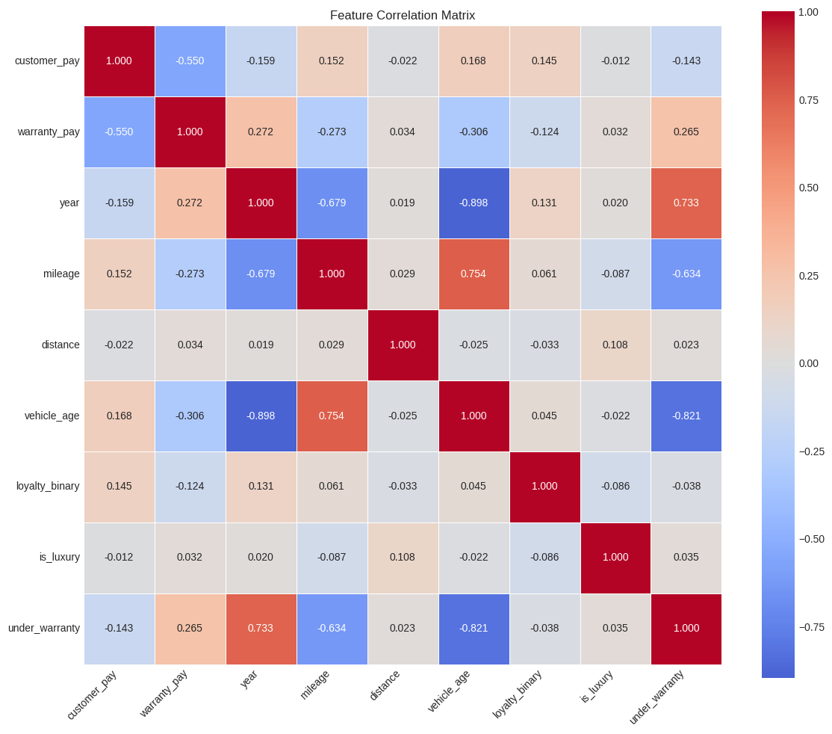
Figure 1: Correlation Matrix

5.2 Visualization:

We developed visualizations to communicate EDA findings. The key charts include:

Loyalty Adoption by Dealer: Bar chart showing Go Card scanning rates across the 7 dealerships. Toyota on the Trail leads, followed by Go Honda at. The bottom three are Norden VW, Kentwood Ford, and Porsche Centre.

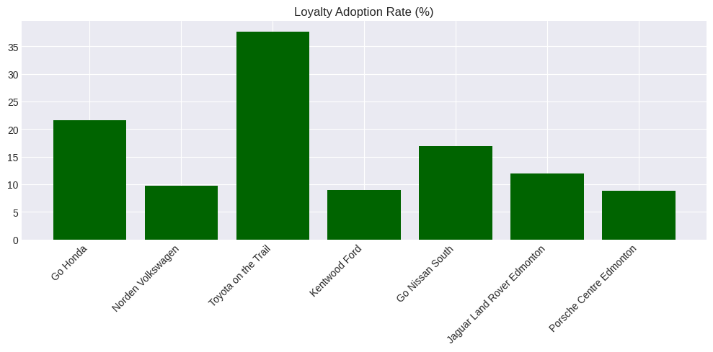
Figure 2: Loyalty Adoption Rate

Revenue Charts: On the revenue side, we plotted average revenue per visit by dealer, which showed a clear split between luxury and volume dealers. Porsche Centre and Jaguar Land Rover both average over $1,150 per visit while Toyota on the Trail sits around $318.

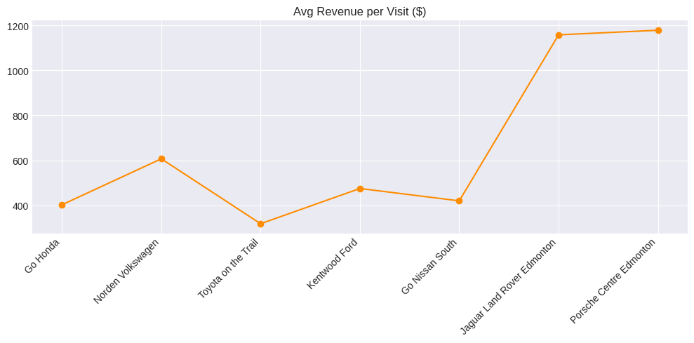
Figure 3 Revenue per Visit
Visit Frequency: This bar chart shows the raw transaction volume split where non-loyalty accounts for roughly 197,974 visits vs. 42,695 for loyalty, reflecting the loyalty adoption gap. While this confirms the scale of untapped potential, raw counts alone are misleading since non-loyalty has far more unique customers.

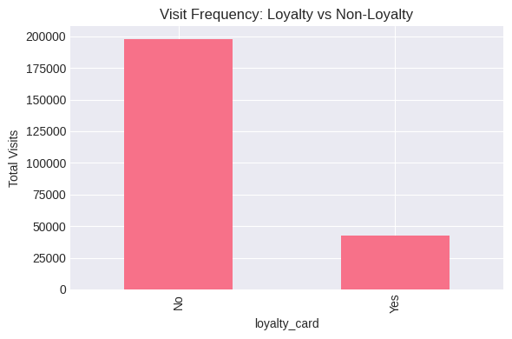
Figure 4: Visit Frequency (Loyalty vs Non-Loyalty)

Distance by Loyalty Status: This boxplot shows that both groups have nearly identical core distributions, medians and IQR boxes sit tight near 0–20 km, meaning most customers live close to their dealership regardless of loyalty status. The real story is the massive number of outliers stretching up to 500 km in both groups, which is why the boxes look compressed at the bottom. Loyalty members average slightly shorter distances (27.0 km vs. 33.2 km), but visually the two distributions are very similar. The difference is likely driven by dealer composition rather than loyalty itself: Toyota on the Trail (highest loyalty) happens to draw more local customers. Phase 2 will control for dealer to test this.

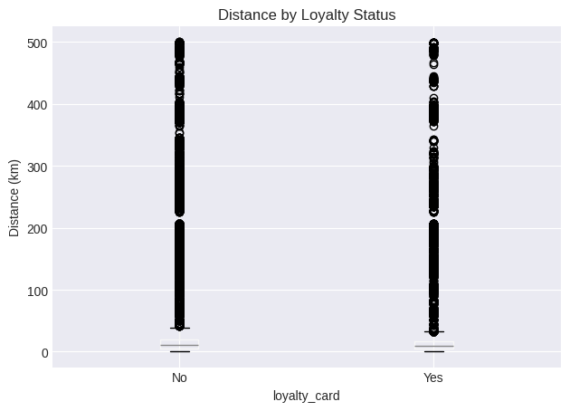
Figure 5: Distance by Loyalty Status

Average Visits per Customer by Make: This chart ranks vehicle brands by how often their owners return for service. Porsche leads at 5.3 visits per customer. The top tier being dominated by luxury and dealer-aligned makes suggests that brand-dealer loyalty drives repeat visits more than the Go Card itself. The long tail of brands averaging 1–2 visits are mostly off-make vehicles (serviced at a dealer that doesn't sell that brand), which naturally see lower return rates. This will be a useful feature for Phase 2 segmentation by distinguishing on-make vs. off-make service behavior.

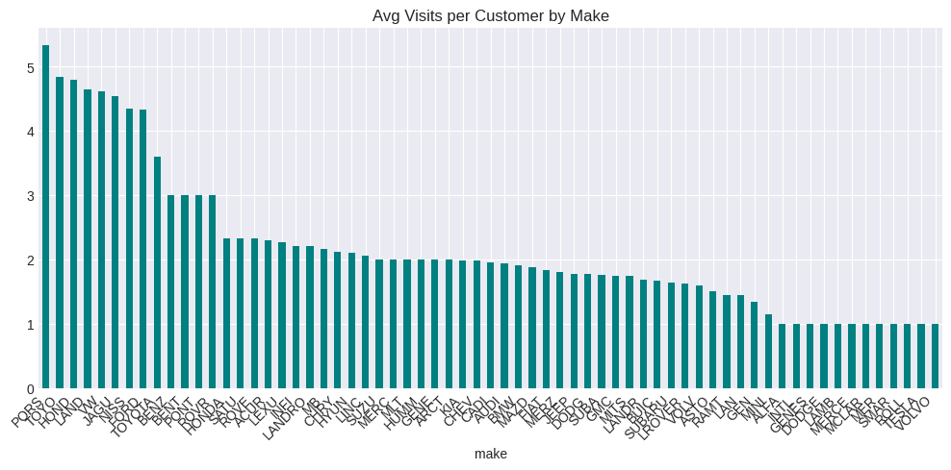
Figure 6: Average Visits per customer by Make

Average Service Revenue by Month (YoY): This chart plots monthly average service cost from 2020 to 2024. The biggest thing that jumps out is that each year sits higher than the last, 2020 hovers around $460–$570 while 2024 is up in the $620–$710 range, so roughly a 35–40% increase over five years. That could be inflation, older vehicles needing pricier work, or shifts in what services people are coming in for. Month to month there's not a huge seasonal swing, maybe a slight bump around June and again near the end of the year, but nothing dramatic.

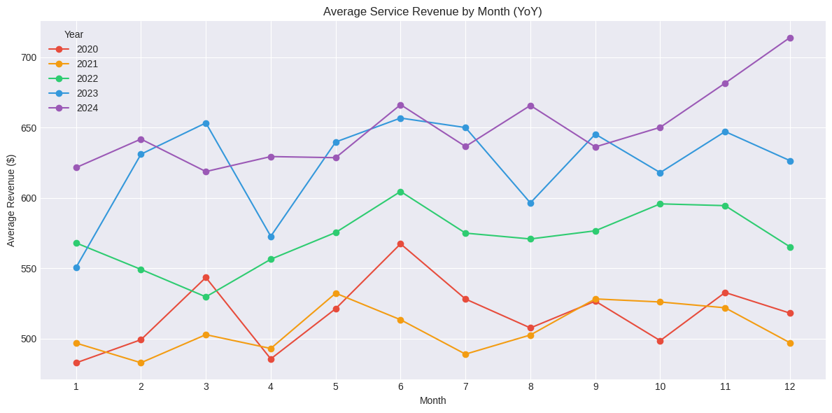
Figure 7: Average Service Revenue by Month (YoY)

Key Findings

- Overall loyalty adoption is just 17.7%, meaning about 82% of service transactions don’t involve the Go Card at all. That’s a pretty big untapped opportunity

Dealer | Total Visits | Loyalty Count | Adoption %
Toyota on the Trail | 39,973 | 15,052 | 37.7%
Go Honda | 49,654 | 10,720 | 21.6%
Go Nissan South | 28,902 | 4,869 | 16.9%
Jaguar Land Rover Edmonton | 26,023 | 3,108 | 11.9%
Norden Volkswagen | 41,359 | 4,053 | 9.8%
Kentwood Ford | 37,716 | 3,389 | 9.0%
Porsche Centre Edmonton | 17,042 | 1,504 | 8.8%
Table 2: Loyalty Adoption Rates by Dealership

- Loyalty members actually travel shorter distances on average (27.0 km vs. 33.2 km). This might be confounded by dealer location – Toyota on the Trail has the highest loyalty rate and may just be in a more central spot. We will control for dealer effects in Phase 2
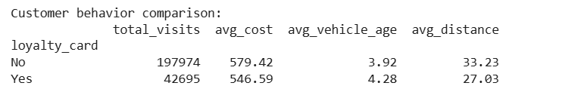
Figure 8: Customer Behavior Comparison

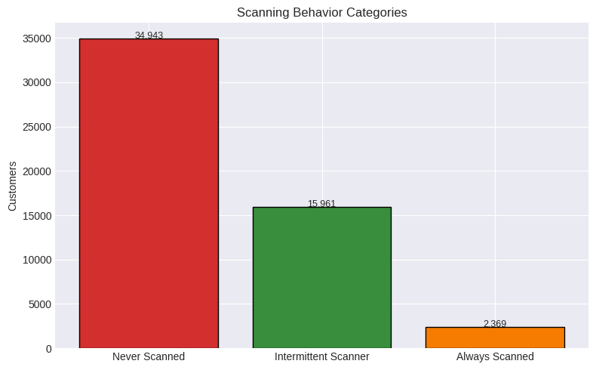
- Intermittent Scanning (Post-Demo 1): After feedback from the GO Auto client, we analyzed loyalty card scanning patterns over time. Out of 53,273 unique customers, 65.6% never scanned their card, 30.0% scanned inconsistently, and only 4.4% always scanned.
Figure 9: Scanning Behavior Categories

Among intermittent scanners with 3+ visits, 53% showed a pattern of starting as non-loyal and then beginning to scan, while only 5.4% started scanning and then stopped. This is a positive sign, meaning the program is converting previously unengaged customers.

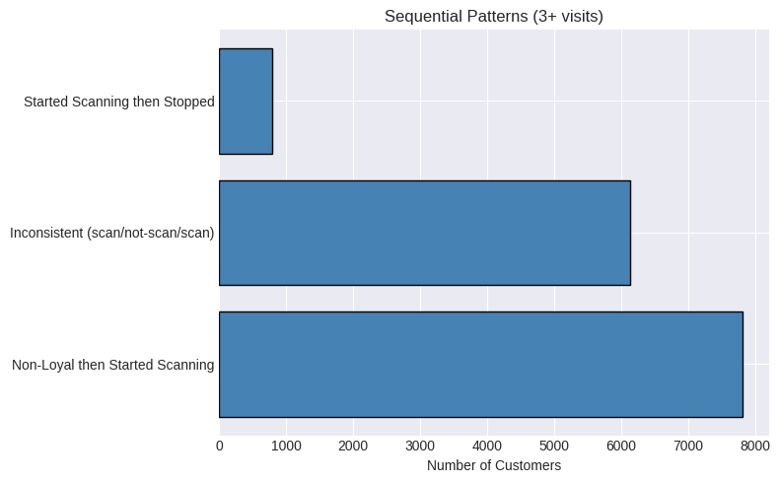
Figure 10: Sequential patterns

From there, we built a refined loyalty treatment classification based on scanning ratios: Non-Loyal, Partially Engaged, and Likely Loyal.
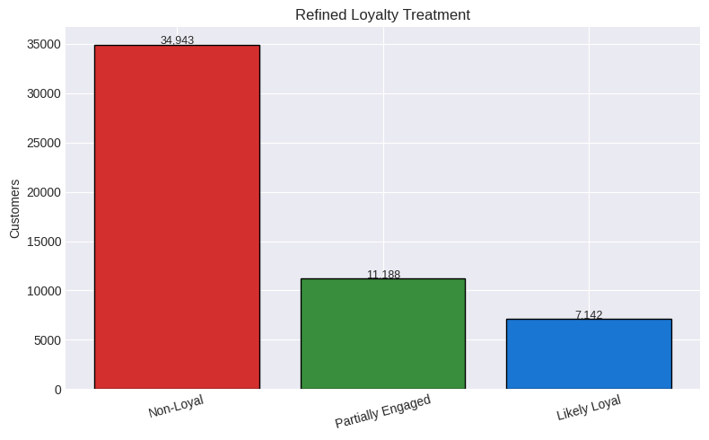
Figure 11: Refined Loyalty Classes

So then we created a grouped bar chart breaks down our refined loyalty categories across dealerships. Toyota on the Trail stands out immediately. It's the only dealer where the Likely Loyal (green) bar is actually competitive with Non-Loyal, with about 3,200 likely loyal customers. Every other dealer is dominated by orange (Non-Loyal), especially Kentwood Ford and Norden VW where the non-loyal count hits around 7,100 each with very small loyal segments. Go Honda has the largest Partially Engaged group around 2,700. Porsche Centre barely registers any loyal or partially engaged customers at all, reinforcing the luxury adoption gap we keep seeing. This chart basically tells us where the low-hanging fruit is: Go Honda and Nissan South have decent partially engaged pools worth targeting, while Kentwood and Norden have the most work to do.

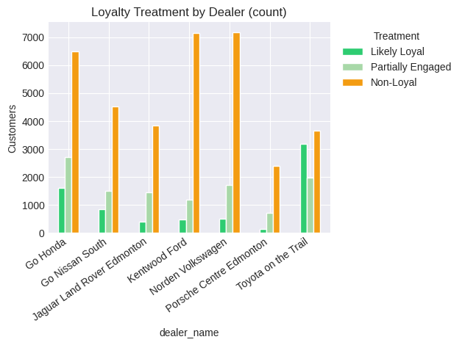
Figure 12: Loyalty Treatment by Dealer

- Same-Day Visit Aggregation: The client asked whether multi-record same-day visits should count as one or many. We found 98.4% of visits have a single record, with 1.6% having 2+ records on the same date. We built an aggregated visit-level dataset (236,781 visits) as an alternative analytical view for Phase 2.
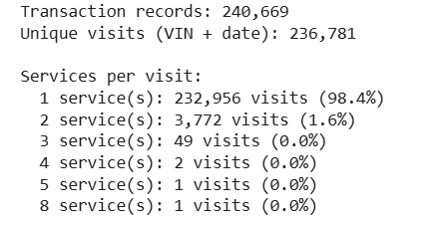
Figure 13: Visit Aggregation

While the visualizations effectively communicated loyalty adoption and behavioral differences, stakeholder feedback highlighted readability issues in certain plots (e.g., axis clarity), which will be improved in the next phase.

Challenges Encountered:

- Understanding Business Context
It was initially challenging to interpret certain missing values and service cost patterns without full operational context.
- Balancing Technical vs Business Perspective
We focused heavily on EDA and preprocessing but initially lacked deeper solution-oriented framing.
- Data Structure Complexity
Transaction-level data required aggregation to extract customer-level behavior.
- We also learned the importance of presenting summarized outputs instead of lengthy code snippets to improve clarity for stakeholders.

We addressed these challenges through:
- Group discussions
- Feature engineering
- Stakeholder feedback integration

Stakeholder Engagement:

We presented our initial EDA findings at Demo 1 on February 13, 2026. Both the GO Auto client team and our instructor provided feedback:

The client was curious about why loyalty scanning is so inconsistent and asked us to look at sequential patterns to see if customers are adopting or dropping off. We addressed this with the intermittent scanner analysis described above.

They also asked us to clarify how we count same-day multiple service records, which led to us building the visit-level aggregation.

The instructor emphasized that outliers need to be actually removed from the dataset, not just flagged, which we implemented in our updated cleaning pipeline.

No additional data was requested from the client at this stage, though we mentioned that having actual Go Card membership records (separate from scan data) would really improve our loyalty analysis. The client acknowledged this as a potential future enhancement.

Lessons Learned:

Lesson 1: Understand the business before touching the data. We found that 82.1% of missing cost values were warranty services. If we had just used a generic median fill, we would have overestimated costs for those records. Knowing why data is missing matters more than picking the fanciest imputation method.

Lesson 2: Always verify findings against the same data. Our conflicting distance insight happened because we compared results from different subsets without realizing it. Going forward, we're keeping one source of truth for key metrics and double-checking aggregated numbers against the raw tables.

Lesson 3: Being transparent pays off. The client specifically called out that they liked seeing our flags for imputed values and outliers. Even when the data has gaps, showing how we handled them builds more trust than hiding the mess.

Lesson 4: Flagging outliers isn't enough — they must be treated. After feedback, we applied domain-based thresholds and removed extreme values (e.g., unrealistic mileage and distance values) to ensure the cleaned dataset is suitable for clustering.

Lesson 5: Client questions uncover things you didn't think of. The client asked how we handle customers who scan their loyalty card sometimes but not always. We hadn't considered that at all. These intermittent scanners need their own classification rather than being lumped into a simple yes/no bucket.

Risk Management:

Data interpretation risk: The loyalty_card field only tells us if someone scanned their card, not whether they actually have one. So there's a real chance we're mislabeling loyal customers as non-loyal just because they forgot their card that day. That's exactly why we built the ratio-based loyalty treatment where it looks at scanning patterns over time instead of trusting any single visit.

Confounding variables: The loyalty adoption differences across dealers might have more to do with whether it's a luxury or volume location (or just where it sits in the city) than how well the program is actually working. We're planning to tackle this in Phase 2 with dealer-controlled comparisons so we can separate out those effects.

Scope creep: Demo 1 feedback from the client added new asks like scanning pattern analysis and visit aggregation weren't in our original plan. We handled it by focusing on the highest-impact additions first and pushing anything lower priority to Phase 2.

Future Recommendations:

Recommendation 1: Cluster customers by behavior. Aggregate visit frequency, spending, distance, and loyalty engagement at the customer level, then apply K-Means to find natural groupings like repeat loyalists, occasional users, and one-time walk-ins.

Recommendation 2: Benchmark dealerships against each other. Cluster the seven dealerships by loyalty adoption, revenue, retention, and service volume so leadership can see which locations are thriving and which need support.

Recommendation 3: Predict who's likely to enroll. Build a predictive classification model to identify customers most likely to enroll in the loyalty program. This gives low-adoption dealerships a targeted list to work with instead of guessing.

Recommendation 4: Look at Porsche separately. Porsche Centre shows significantly lower loyalty adoption compared to other dealerships and should be analyzed separately. Comparing luxury vs. volume dealerships could show that a one-size-fits-all loyalty strategy doesn't work across the board.

Impact on the Community:

Improving customer retention and loyalty performance can:
- Increase dealership efficiency
- Improve service scheduling planning
- Enhance customer satisfaction
- Support local dealership growth in Edmonton

Project Conclusion:

Phase 1 established a strong analytical foundation for understanding Go Auto’s service dataset and loyalty program performance. We validated data quality by examining duplicates, missing values, and variable types to ensure reliable analysis. Through exploratory data analysis, we identified key patterns related to loyalty adoption, visit frequency, spending behavior, and dealer-level variation across the seven Edmonton dealerships.
Our findings indicate that loyalty membership is associated with higher engagement and spending, which aligns directly with Go Auto’s business objective of improving customer retention after the warranty period. Additionally, we engineered behavior-based features, refined loyalty classification through sequential scanning analysis, created a visit-level aggregated dataset to ensure accurate frequency metrics, and conducted correlation analysis to prepare a structured dataset for clustering in Phase 2.

Although our analysis quantified loyalty impact (visit frequency, spending, lifetime value), in Demo-1 we did not always explain these findings deeply or clearly enough during the oral presentation, which we aim to improve in future demos.

Acknowledgments:

We would like to thank the GO Auto team for sharing the dataset and for the solid feedback during Demo 1. The questions they raised about scanning patterns and same-day visits pushed us to dig deeper and our analysis is better for it. Thanks also to our instructor for keeping us honest on data quality (especially the outlier removal call). And of course, thanks to NorQuest College and the CMPT 3830 course for setting up this WIL experience in the first place.

Appendices:

Our sprint logs and scrum notes are in the Team ALPACA Scrum Template spreadsheet, which we've included with this submission. We ran weekly sprints and tracked task assignments, progress, and what worked or didn't in retros.

All the code behind this report lives in our EDA notebook (cmpt3830_phase_1_go_auto_from_feedback.ipynb) on our GitHub repo where every chart, table, and number in this report can be traced back to that notebook.

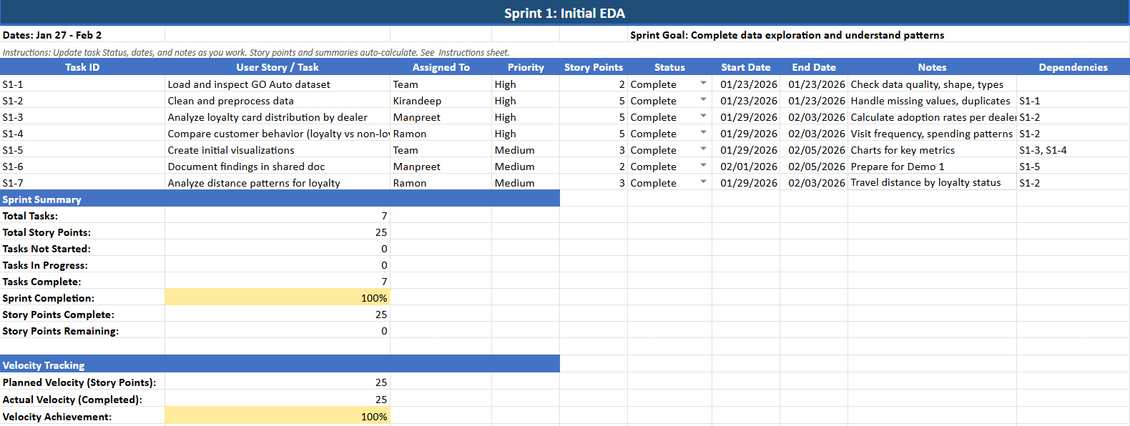
Figure 14: Sprint 1

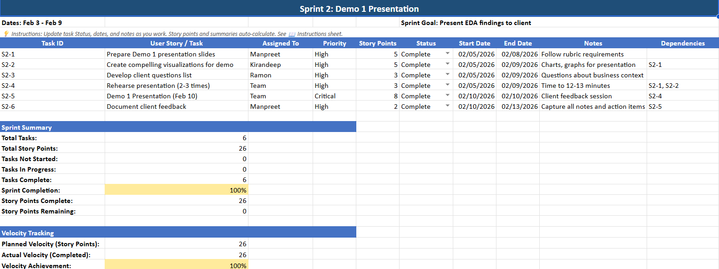
Figure 15: Sprint 2

References
Cite your sources (MUST follow APA style).

